JOB SEEK

Roll-No-1919 

**Introduction**: Is an app designed to search and post jobs. On the whole the objective of the project is to job seeker post their resume, search for jobs, view personal job listings, save jobs and apply for job directly from portal. Where as the job poster can post the vacancies and check out the candidates who have applied for the vacancy and can select or discard the apply request sent.

**Modules**:

1. Register
2. Log in
3. Create/Update Profile
4. Post/Update/Delete Job
5. Search Job (by category ,title)
6. Save job
7. Apply for Job
8. Check Candidates applied for job
9. Accept/Decline Job request
10. Log out

**Existing System And Limitations**: There are many other job provider app/portal but they do not have a direct communication. Jobseeker’s have to navigate from app to the job provider’s website/app through link to apply for the job or email the resume to the provided email address described on the page.

**Scope**: The Scope can be as follows:

1. Maintain jobseeker and employee records.
2. Provides customised job posting.

**Proposed System**: User need not navigate to other website to apply for the vacancy. There is a built in apply for job feature .This makes the app more user

**Screen Shots**

­­­­­­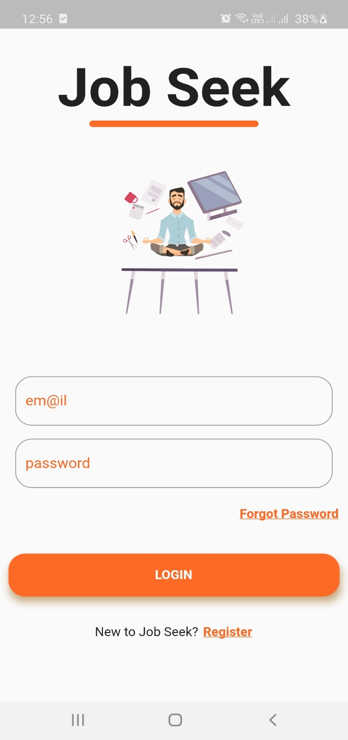 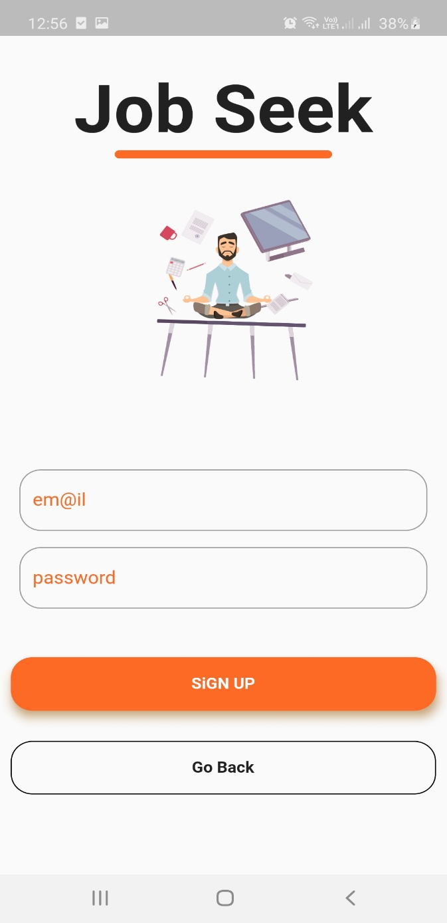

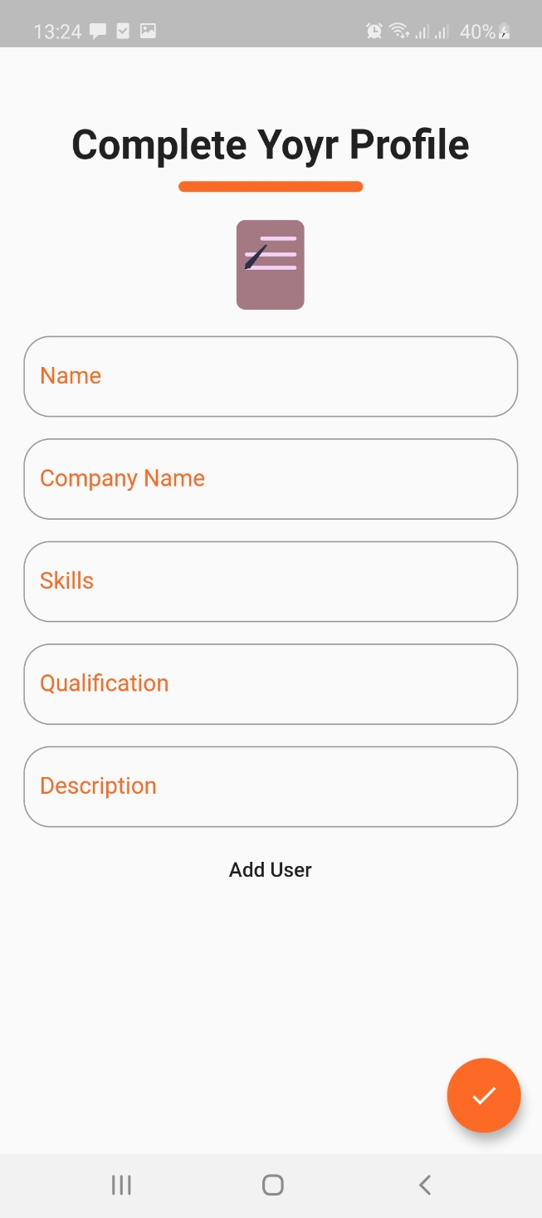 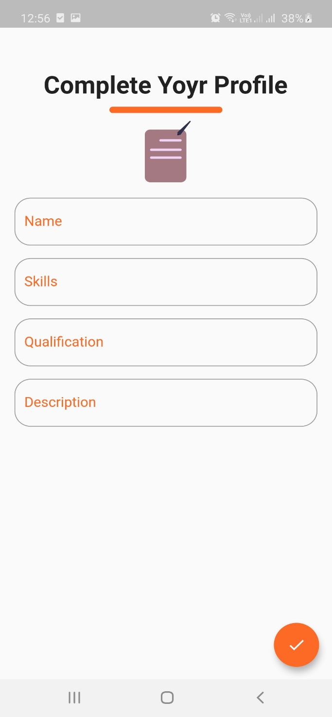

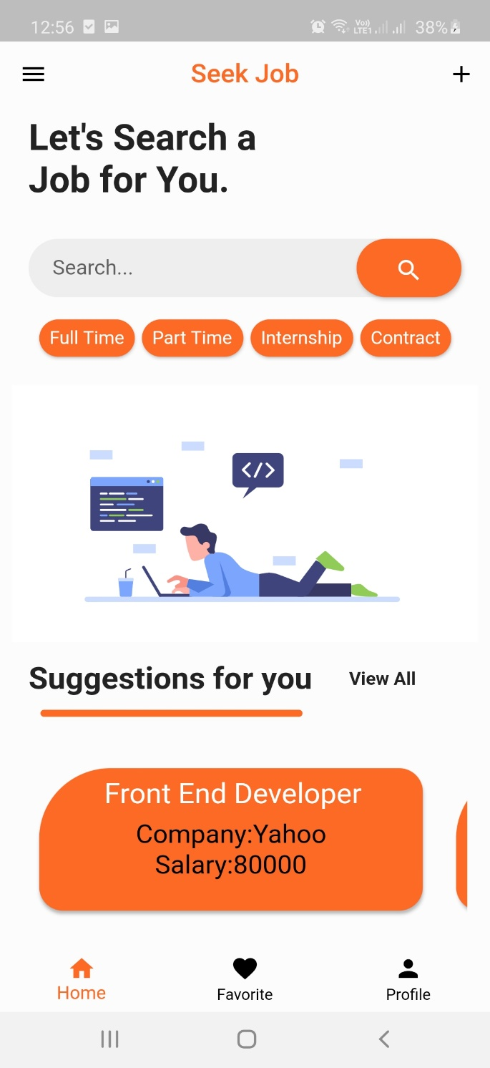 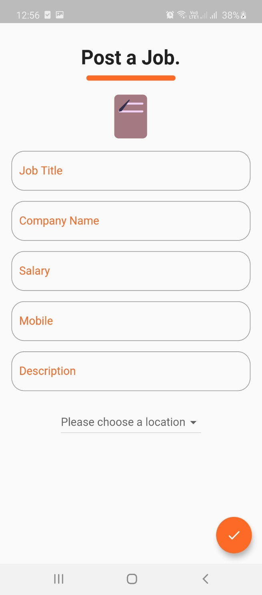

**ERD**

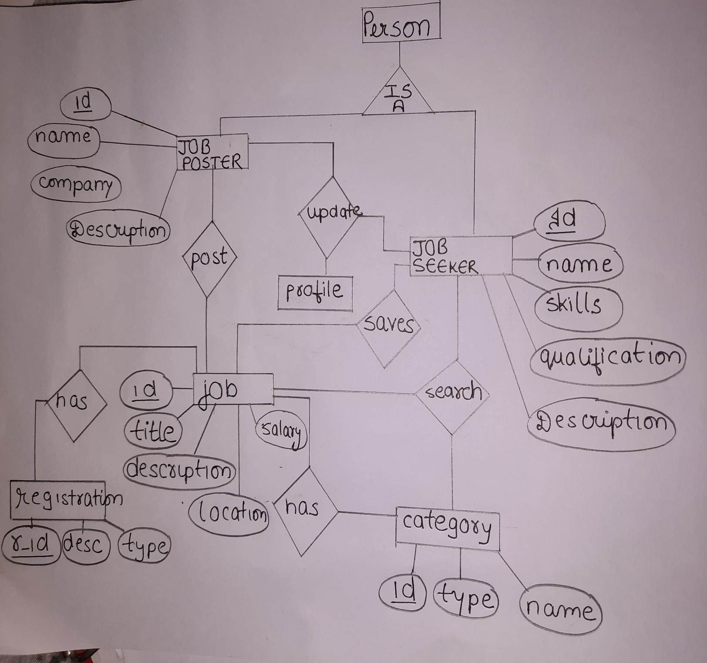

**UML Diagram:**